IN-GEL SAMPLE DIGESTION PROTOCOL
REAGENTS REQUIRED
1. Ammonium bicarbonate (Sigma A6141) - working concentration 50 mM
2. Dithiothreitol (Sigma D5545) - working concentration 100 mM
3. Iodoacetamide (Sigma I1149) - working concentration 200 mM
4. MS grade Trypsin (Sigma T6567) - working concentration 13 ng /µl
5. Formic acid (Merck 5.33002.0050)
6. Acetonitrile (Merck 1.00029.2500)
REAGENT SETUP (prepare freshly before use)
1. Destaining solution: 100 mM ammonium bicarbonate/ acetonitrile (1:1, v/v)
2. Formic acid 5% in milliQ water (v/v).
3 Extraction buffer: 5% formic acid/acetonitrile (1:2, v/v)
4. Trypsin buffer: 13 ng /µl trypsin in 50 mM ammonium bicarbonate.
PROCEDURE
1. Wipe the glass slides, scalpel with methanol. Excise the protein band from acrylamide gel with the scalpel on a glass slide avoiding the unstained gel region.
2. Chop excised bands into small cubes of 1 x 1 mm size and transfer the pieces into duly labelled 1.5 ml centrifuge tubes.
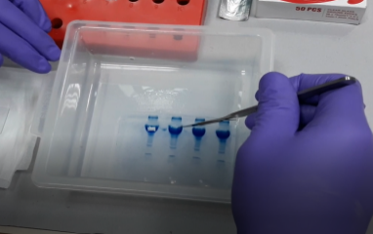
. 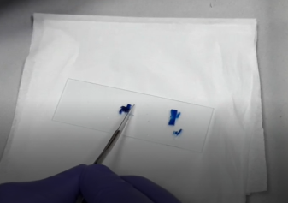 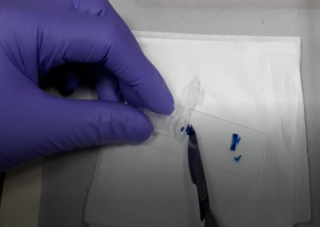
3. Rinse the gel bands with milliQ water for 1 hour by vortexing @1500rpm.
4. Discard the water and repeat the rinsing step for another 1 hour with 1 ml of fresh milliQ water.
5. Spin gel cubes at 3000 rpm for 20 seconds and remove the water completely.
6. Add 300 µl of destaining solution and vortex for 30 minutes @1500 rpm, depending on the staining intensity.
7. Add 500 µl of 100% acetonitrile and incubate at room temperature with vortexing for 10-15 minutes or until the gel pieces become white and shrink.
8. Remove acetonitrile completely and keep the vials open for 20 minutes for the solvent to evaporate completely.
4. Add 30-50 µl of 13 ng/ µl trypsin buffer in such a way that it covers the dry gel pieces and leave it in an ice bucket or a fridge for saturating the gel.
9. After 30 minutes, check the level of trypsin buffer and if necessary, add more trypsin buffer for the gel pieces to be completely covered with trypsin buffer during the digestion step.
10. Leave the gel pieces for another 90 minutes to saturate them with trypsin buffer. Check the levels of trypsin buffer in the vials again to see if the gels are remaining submerged. If needed, add 10-20 µl of ammonium bicarbonate buffer so that the gel pieces remain wet during enzymatic cleavage.
11. Incubate the vials at 37ºC at 300 rpm overnight with gentle vortexing.
12. Remove the trypsin buffer from the sample vials to respective freshly labelled 0.6 ml of microcentrifuge tubes.
13. Add the extraction buffer (twice the volume of trypsin buffer used initially, usually 100µl) to the sample tubes containing gel pieces and vortex vigorously for 20 minutes.
14. Aspirate the extraction buffer and combine it with the 0.6 ml microcentrifuge tubes.
15. Dry the entire samples using Speed Vacuum concentrator and store at -20 until use.
16. Finally reconstitute the samples in 30 µl of 3% acetonitrile before the LC/MS analysis.

